12.FOREIGN TRADING SYSTEM

COMPONENT DIAGRAM

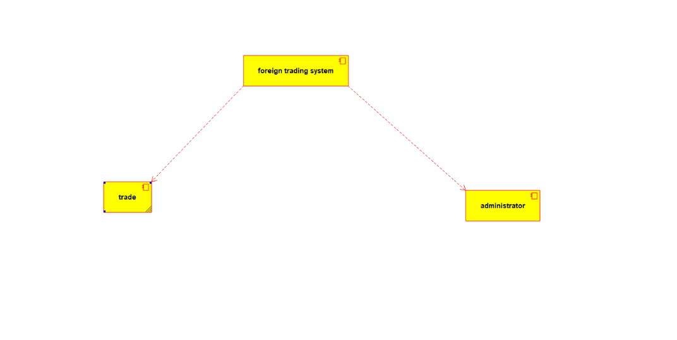

CLASS DIAGRAM

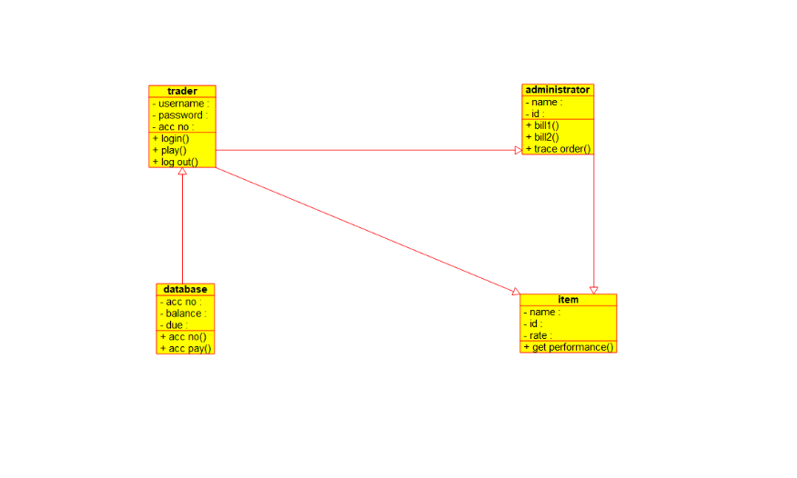

USE CASE DIAGRAM

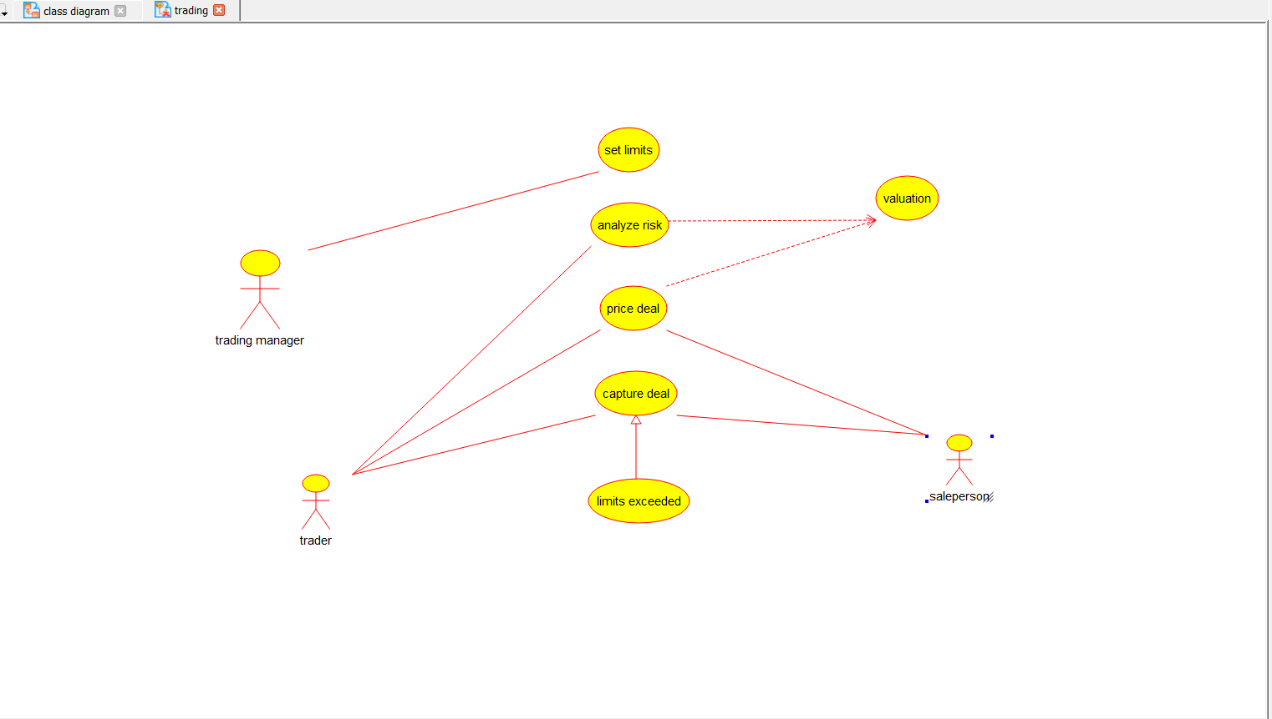

DEPLOYMENT DIAGRAM

